UAE Para Dressage Performance Programme Athletes Complete FEI Classification Marking Key Step on Road to 2028 Paralympic Games
Abu Dhabi, United Arab Emirates, 24 June 2025 – The Royal Stables in Abu Dhabi is proud to announce a significant milestone in its Para Dressage Performance Programme, launched earlier this year to develop a UAE national team for the 2028 Los Angeles Paralympic Games. Since April, several Emirati athletes have joined the pioneering training pathway, and now, two of them have officially completed their FEI classifications, putting them firmly on the road to LA 2028.
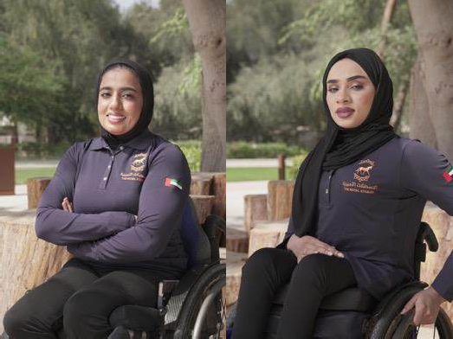
L-R: Fatima Al Bluoshi and Wafaa Aldahmani

Fatima Al Bluoshi and Wafaa Aldahmani, both 31 years old and from Ras Al Khaimah, have been undergoing intensive weekly training at The Royal Stables since their enrolment on the programme in April, alongside their fellow athletes. Their regimen includes riding lessons, theory sessions, simulator training, physiotherapy and sports psychology. The programme is built on a holistic approach designed to nurture both technical knowledge, athlete fitness and mental resilience.

Alongside the training modules, the athletes are supported by experts in sports physiotherapy, psychology and nutrition to enhance performance and optimise wellbeing.

In June, Fatima and Wafaa travelled to Wellington Riding in the United Kingdom, where they undertook their official FEI Para Dressage classification assessments. Fatima, who has lived with spina bifida affecting her lower limbs since birth, was classified as Grade III, while Wafaa, who experienced lower limb paralysis following contracting Polio as an infant, was classified as Grade II.

Their time in the UK also included daily training, attending the CPEDI (Concours Para- Équestre de Dressage International), and connecting with members of Team GB’s multi-gold medal-winning Paralympians. The trip provided invaluable opportunities for technical development and international exposure.

Dr. Russell MacKechnie-Guire, Technical Lead for the UAE Para Dressage Performance Programme, accompanied the athletes on the trip. An internationally recognised expert in equine biomechanics and performance analysis, Dr. MacKechnie-Guire commented:

"This was a defining moment for the athletes and the programme. The FEI classification is essential for any para dressage rider aspiring to compete internationally, and to see Fatima and Wafaa approach this with such professionalism and determination was exceptional. The experience of training daily, watching elite competition and engaging with Team GB’s riders gave them, and us, a clear picture of the standards we are working towards. It is the start of an exciting journey, and both athletes have shown they belong on this path."

The Para Dressage Performance Programme remains open to aspiring Emirati athletes of determination and continues its talent identification and development efforts, with several other athletes already participating in training sessions at The Royal Stables.

Laura Richardson, Performance Manager at The Royal Stables, added:

"Fatima and Wafaa’s progress is inspiring, not just for the equestrian community but for the UAE as a whole. This programme was created to break barriers, and in just two short months together, we have already achieved the first key milestone on our exciting journey to LA 2028."

The Royal Stables continues to invite applications from eligible athletes, along with support from sponsors and partners eager to be part of this historic and inspiring journey.

– ENDS –

About The Royal Stables
Established in 1969 by His Highness the late Sheikh Zayed bin Sultan Al Nahyan, The Royal Stables is a sanctuary of peace and tranquillity in the heart of Abu Dhabi. The property boasts verdant riding trails, abundant stabling and paddocks, along with a Pony Club, yoga studio and café. Currently undergoing a major refurbishment, once complete The Royal Stables’ 32- hectare estate will feature a luxury Members’ Club and boutique hotel with farm-to-table dining concepts, spa & wellness facilities, multiple event spaces and world-class equestrian facilities, including an all-new indoor arena to host international competitions.

Press Information and Contacts Hannah McCabe
Founder, Dark Horse Communications hannah@wearedarkhorse.co
+971 (0)52 6100577
Digital Press Kit with assets can be found here.

